Step By Step

* Create Work Space

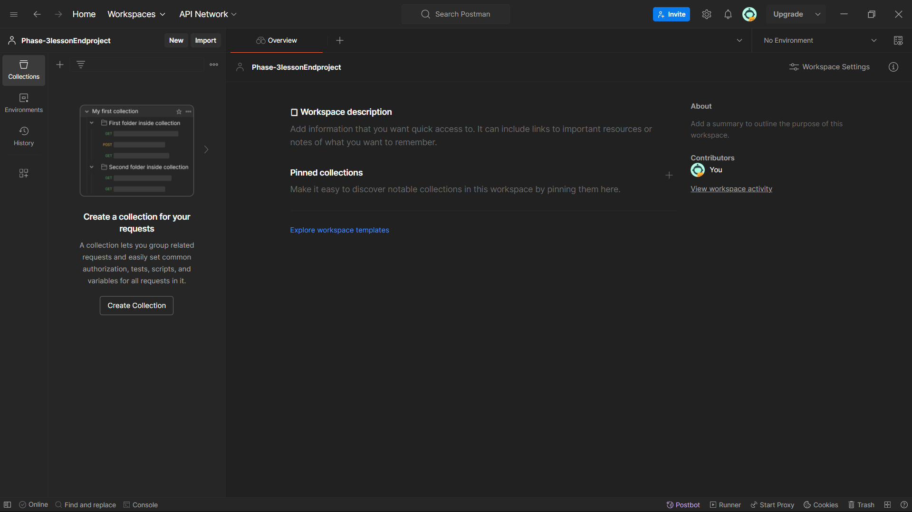

* Create Collection

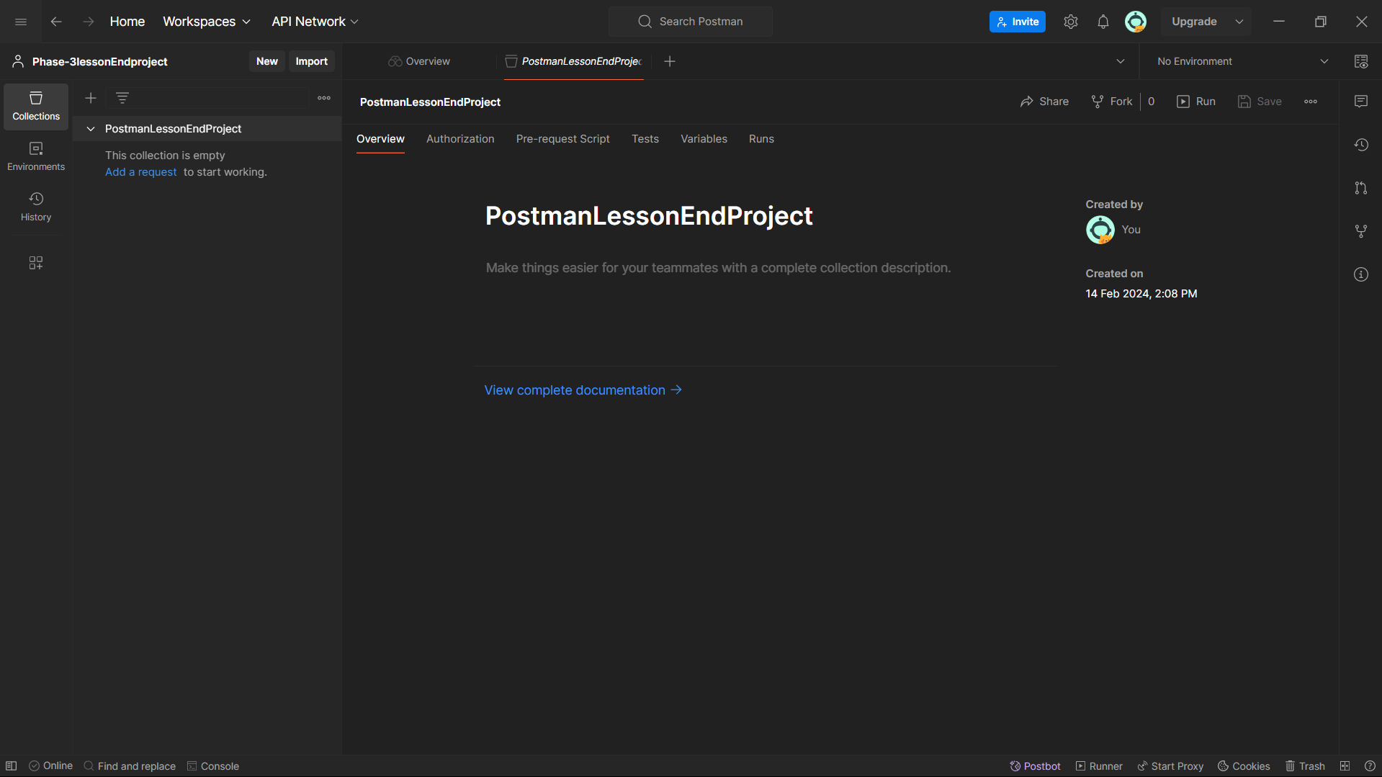

* Create a request in the collection

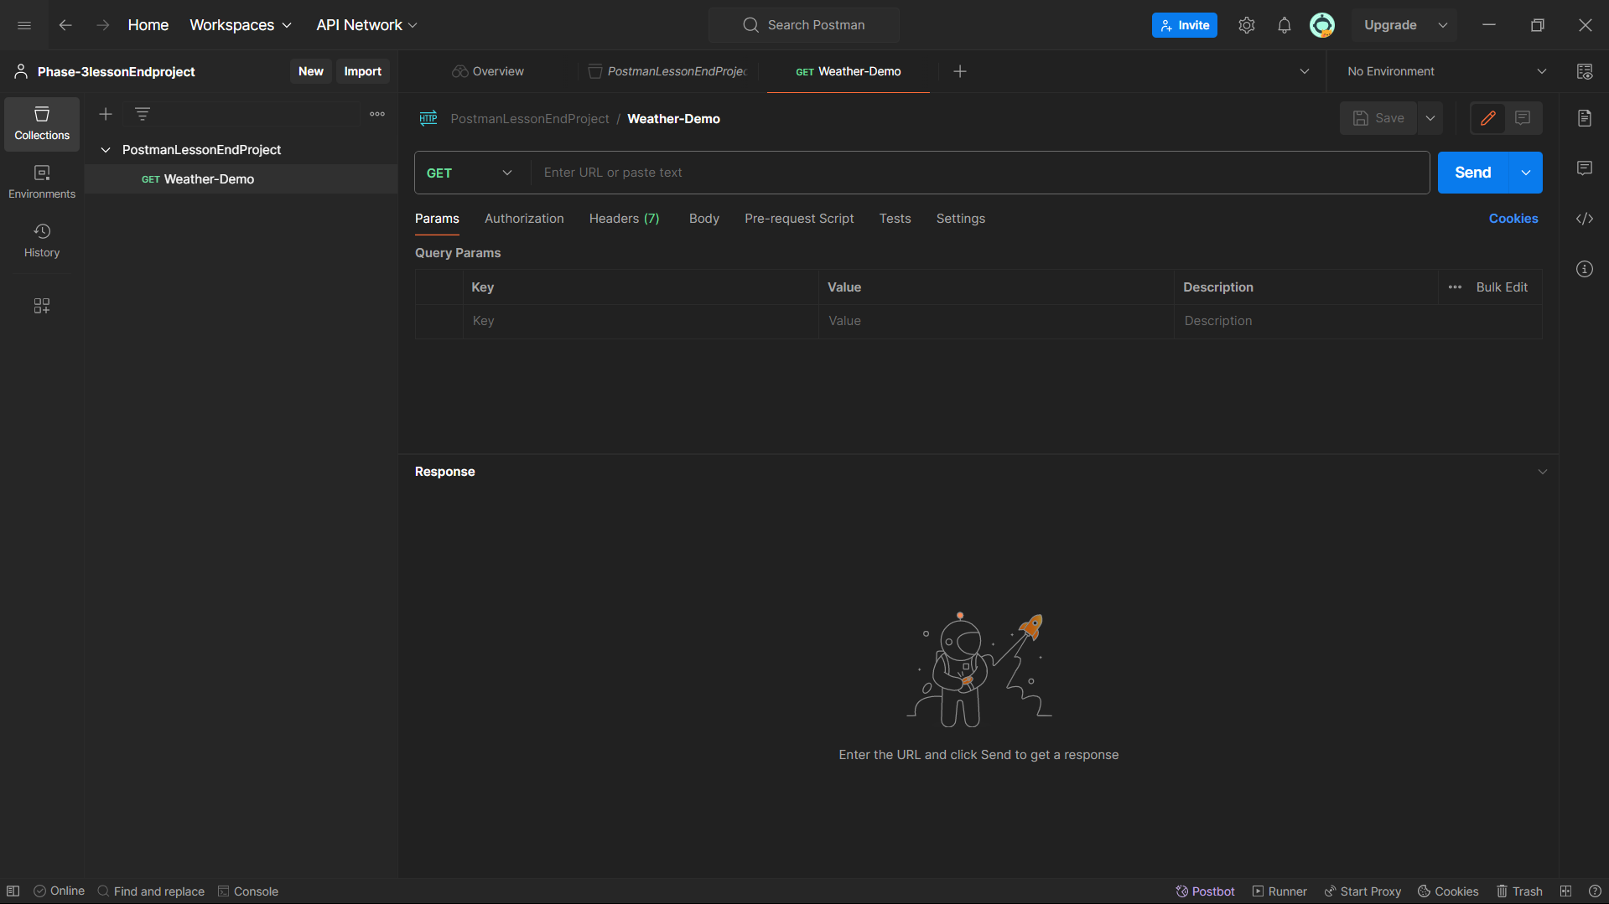

* Past the link in the Get

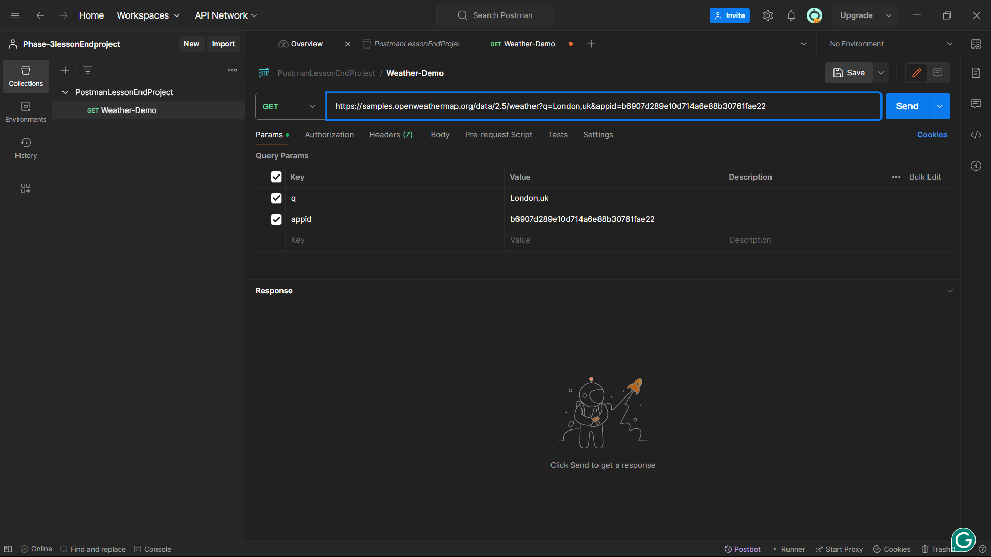

* Save and send

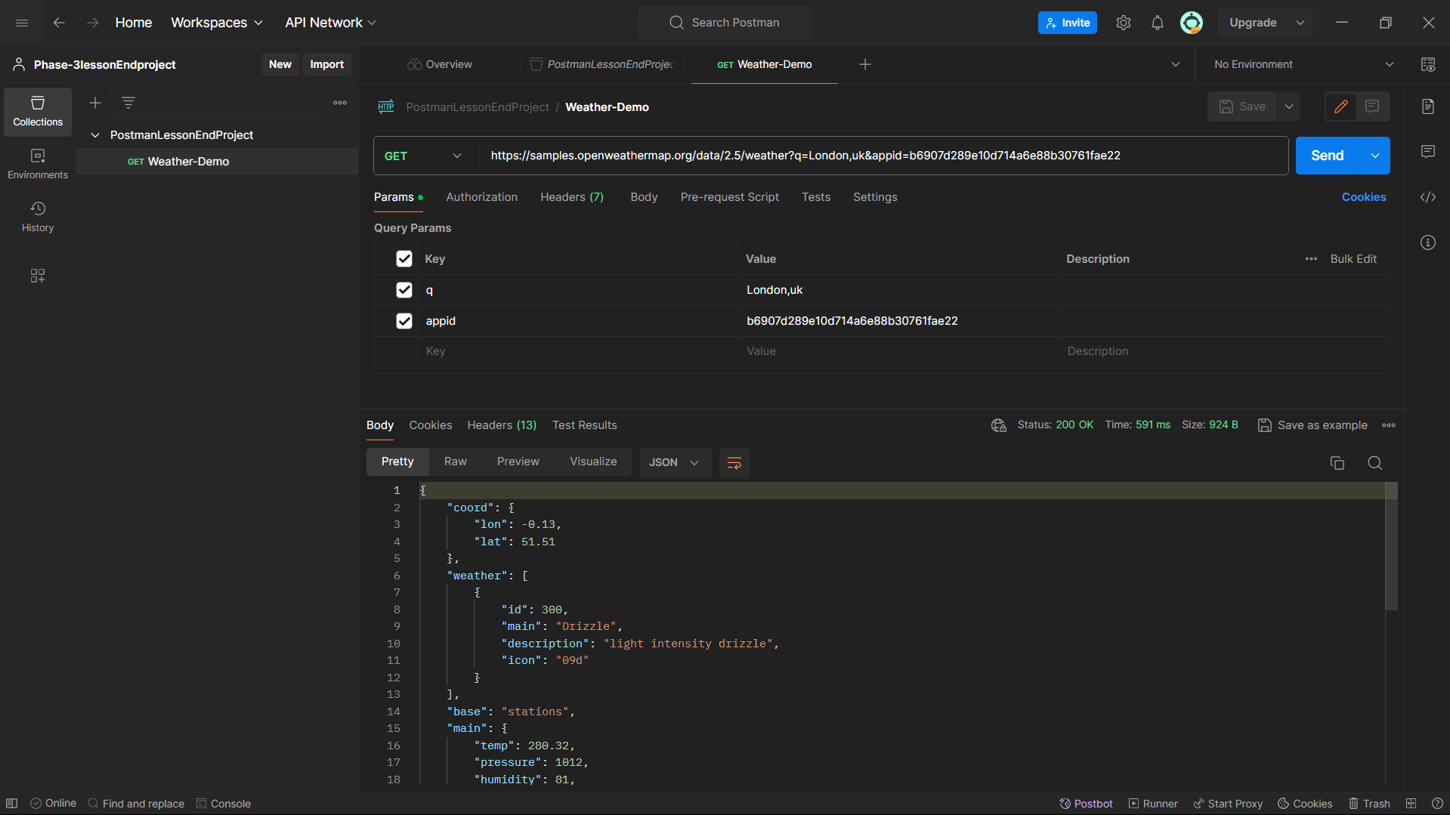

* Create Environment

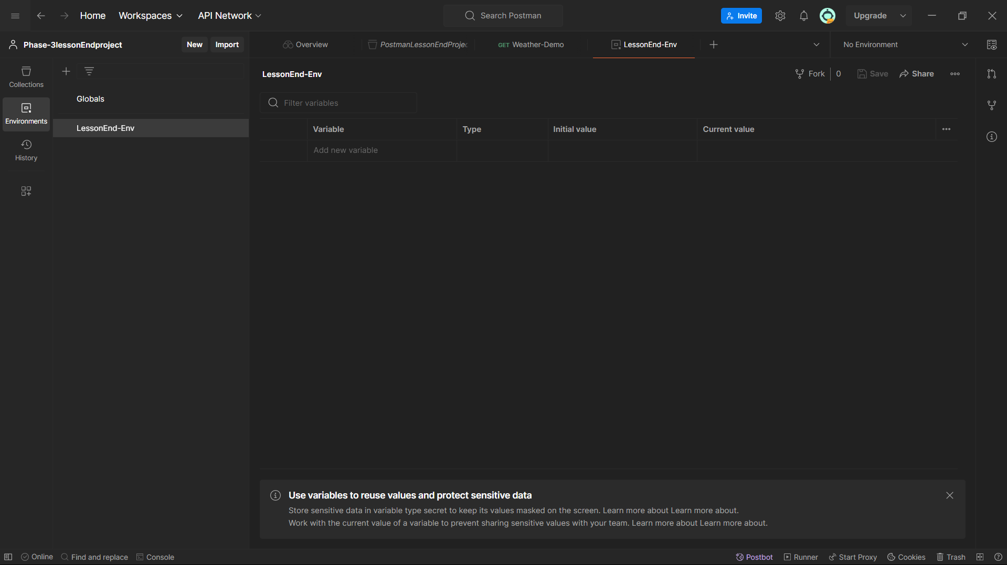

* Add Base_url

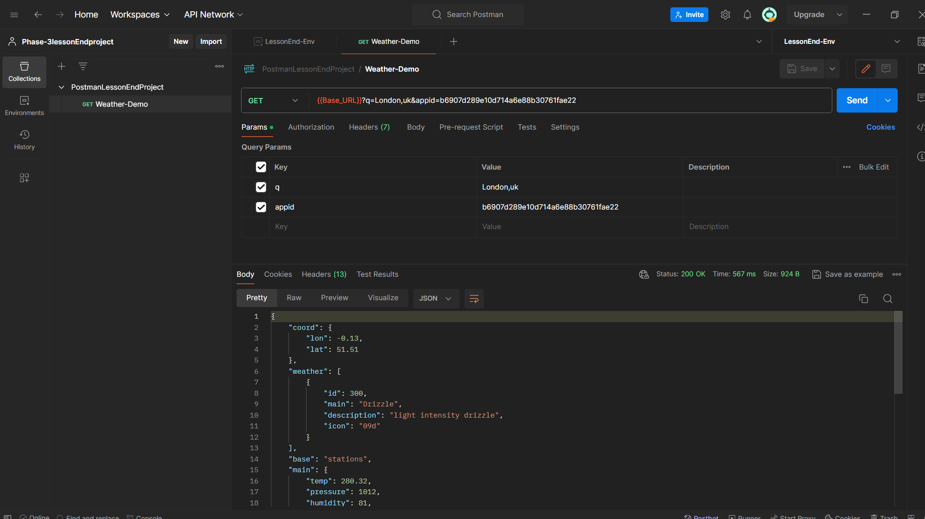

* Add City to the environment

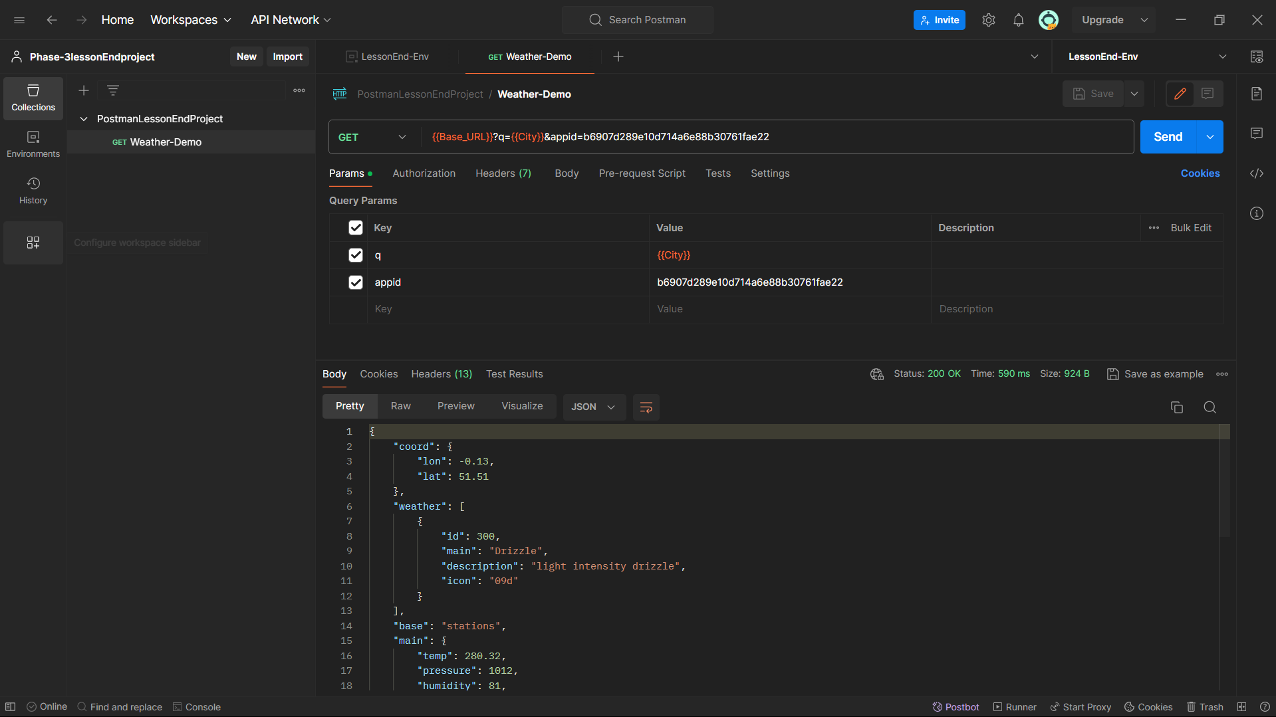

* **Add Appid in Environment**

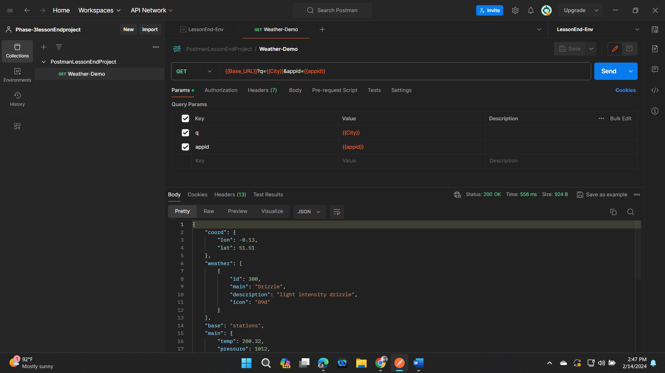

* Add script in the test in the request
* pm.test("validate status code", *function* ()
* {
* pm.response.to.have.status(200);
* } );
* pm.test("validate response message", *function* ()
* {
* pm.response.to.have.status("OK");
* }
* );
* pm.test("validate response time", *function* ()
* {
* pm.expect(pm.response.responseTime).to.be.below(1000);
* }
* );

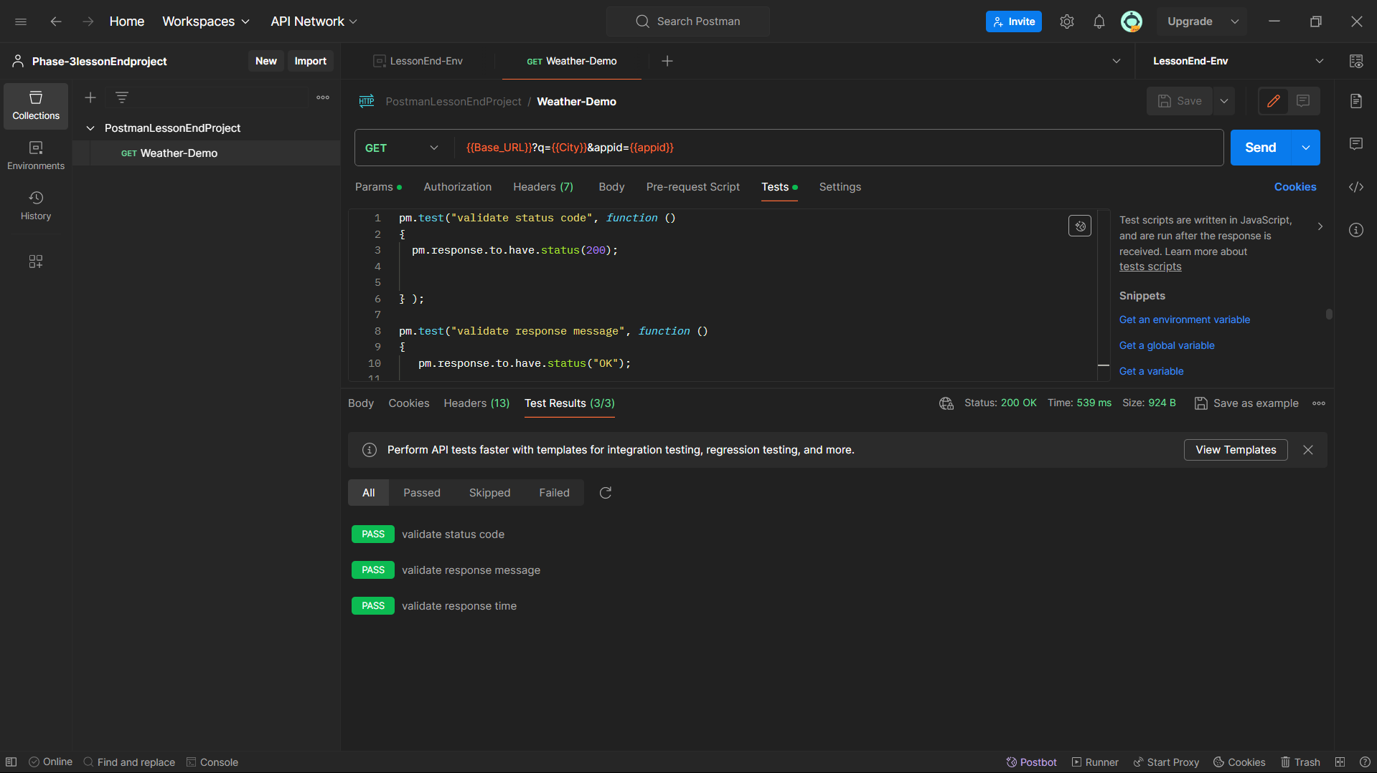

* Set to monitor

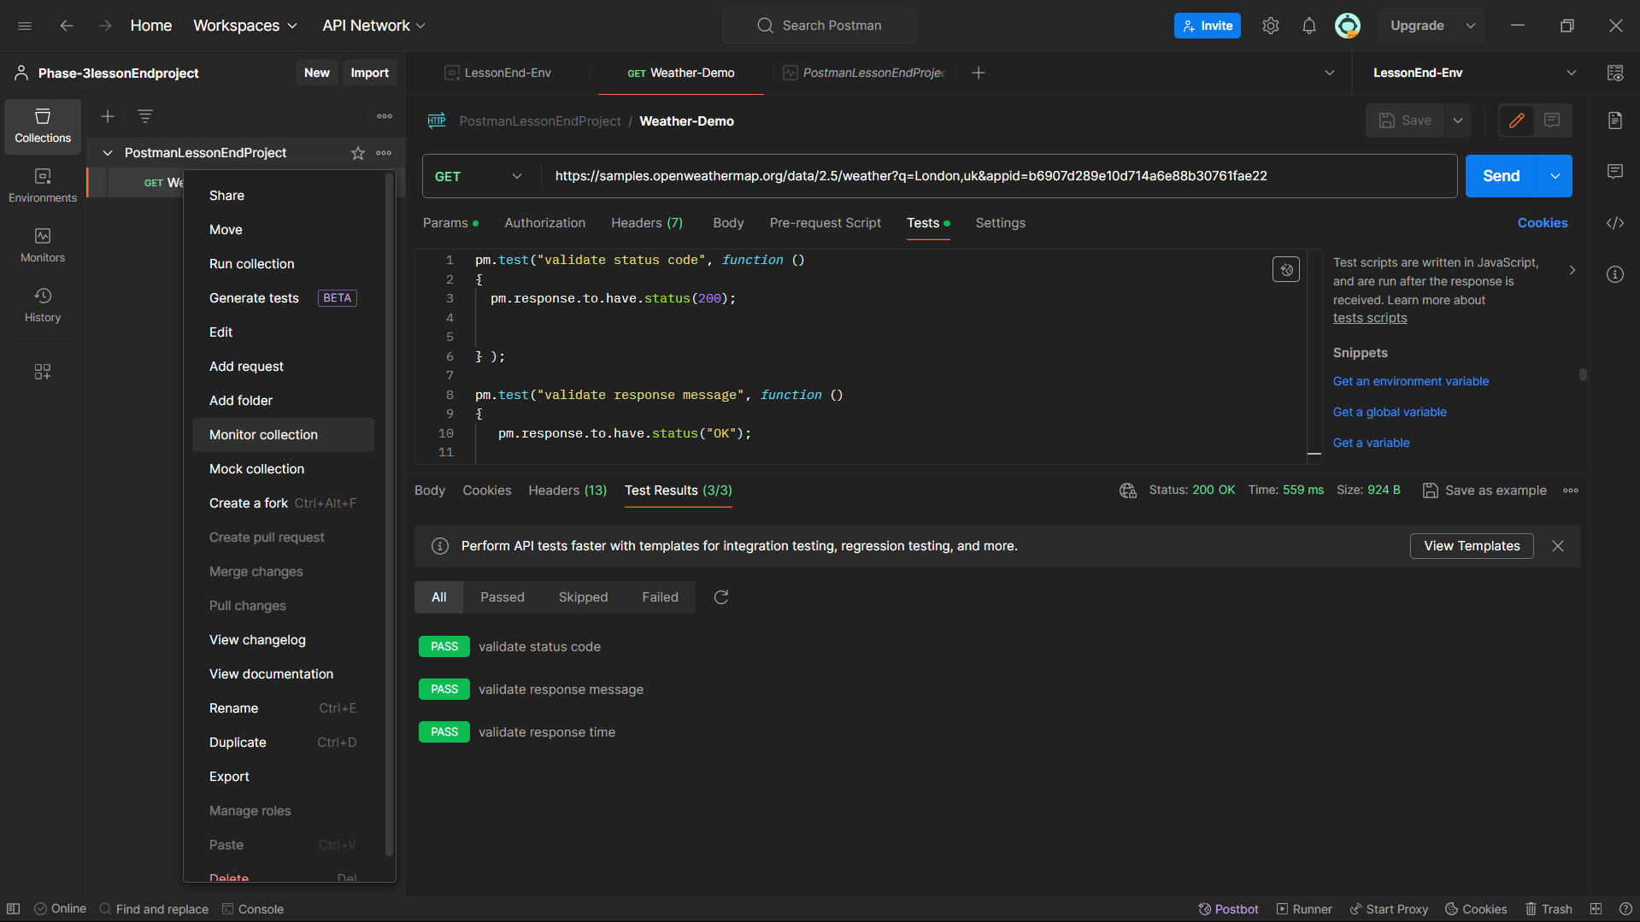

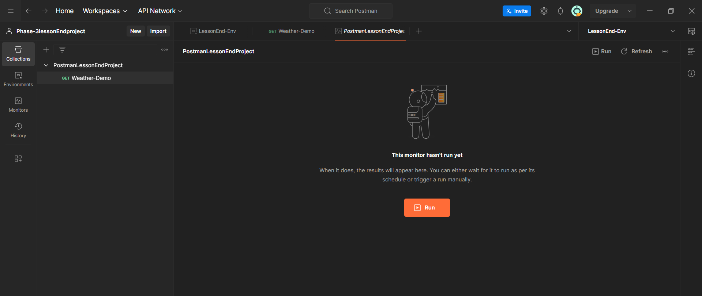

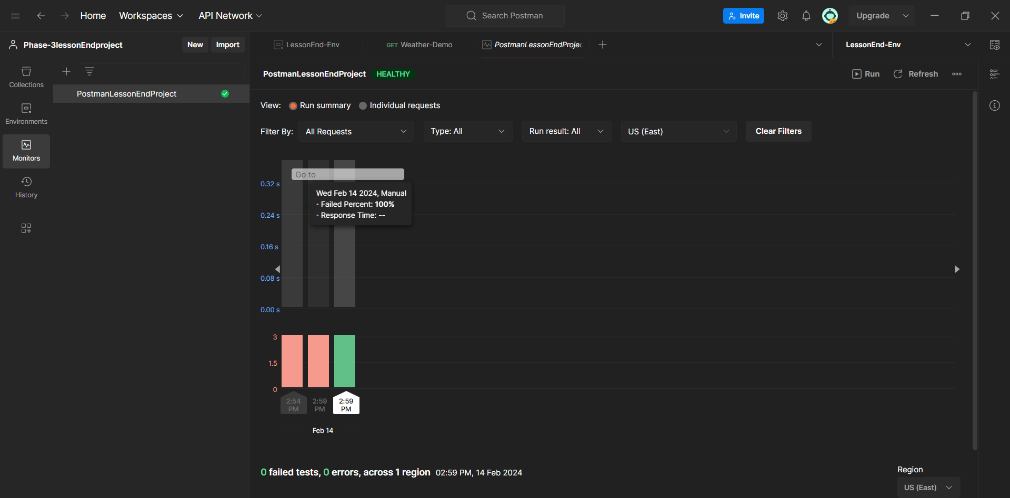

* Newman

1. Export collection

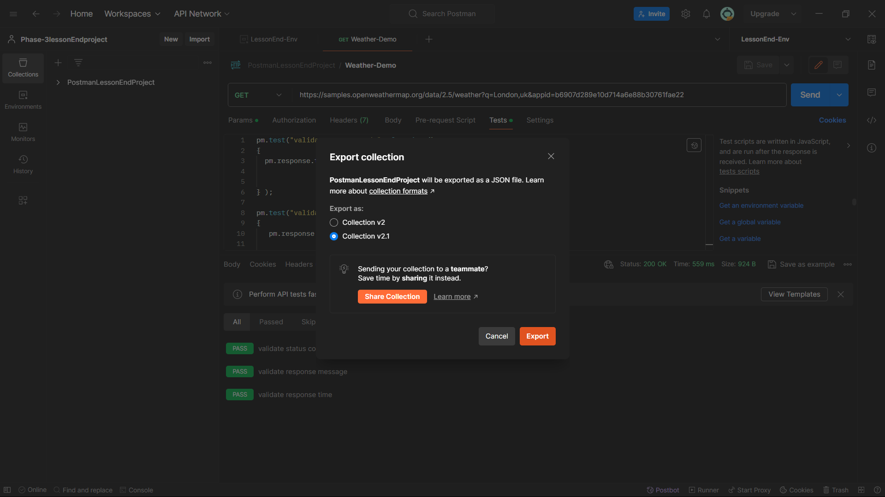

1. Export Environment

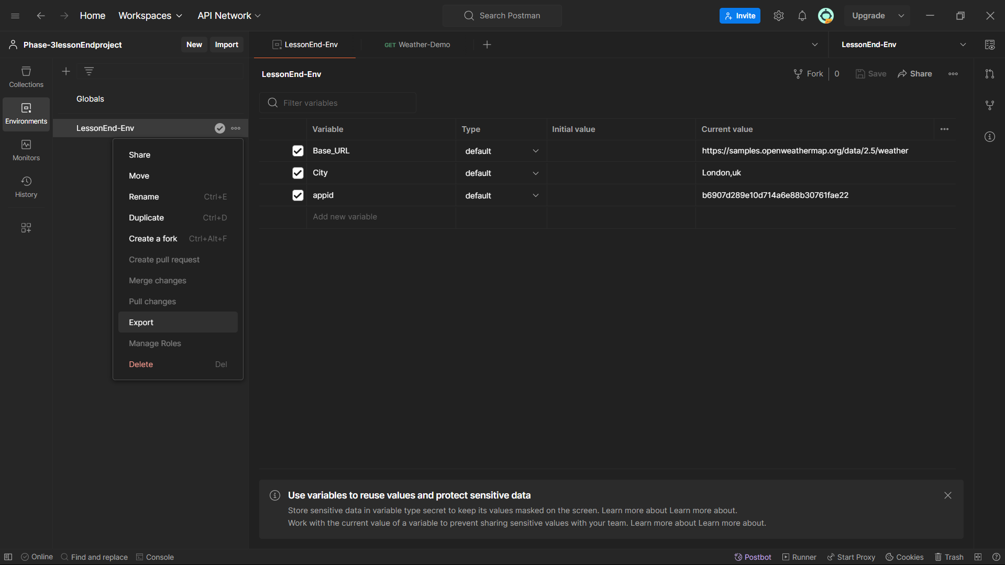

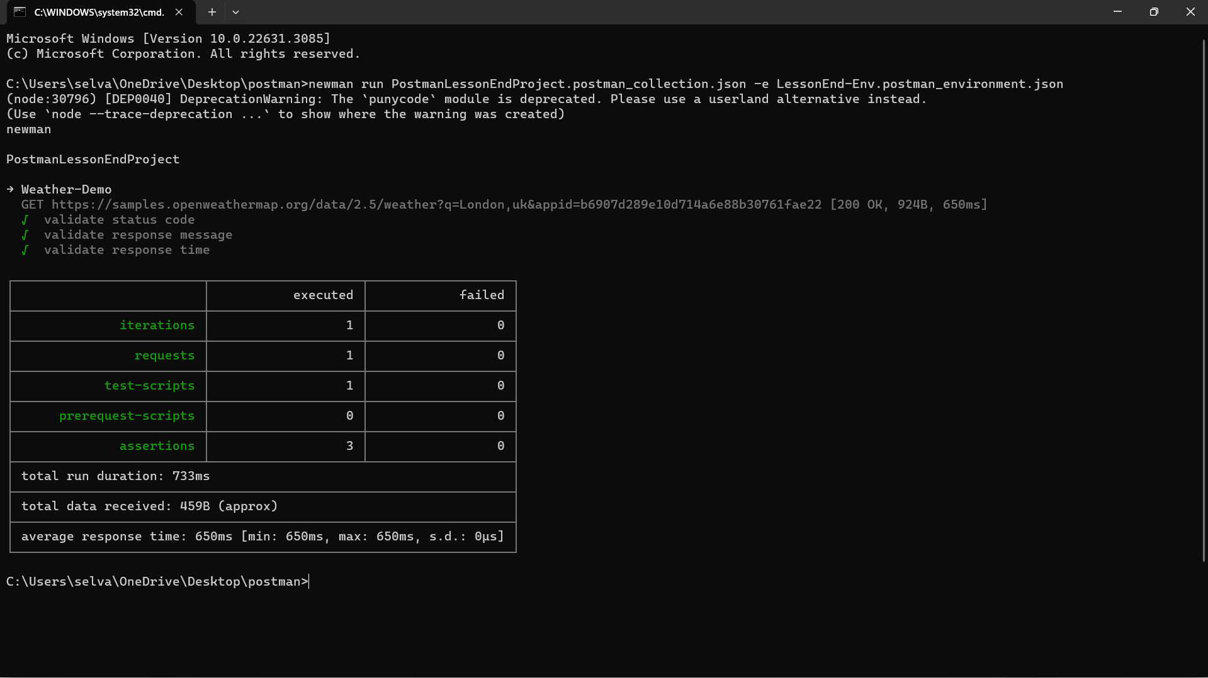

* Push to github

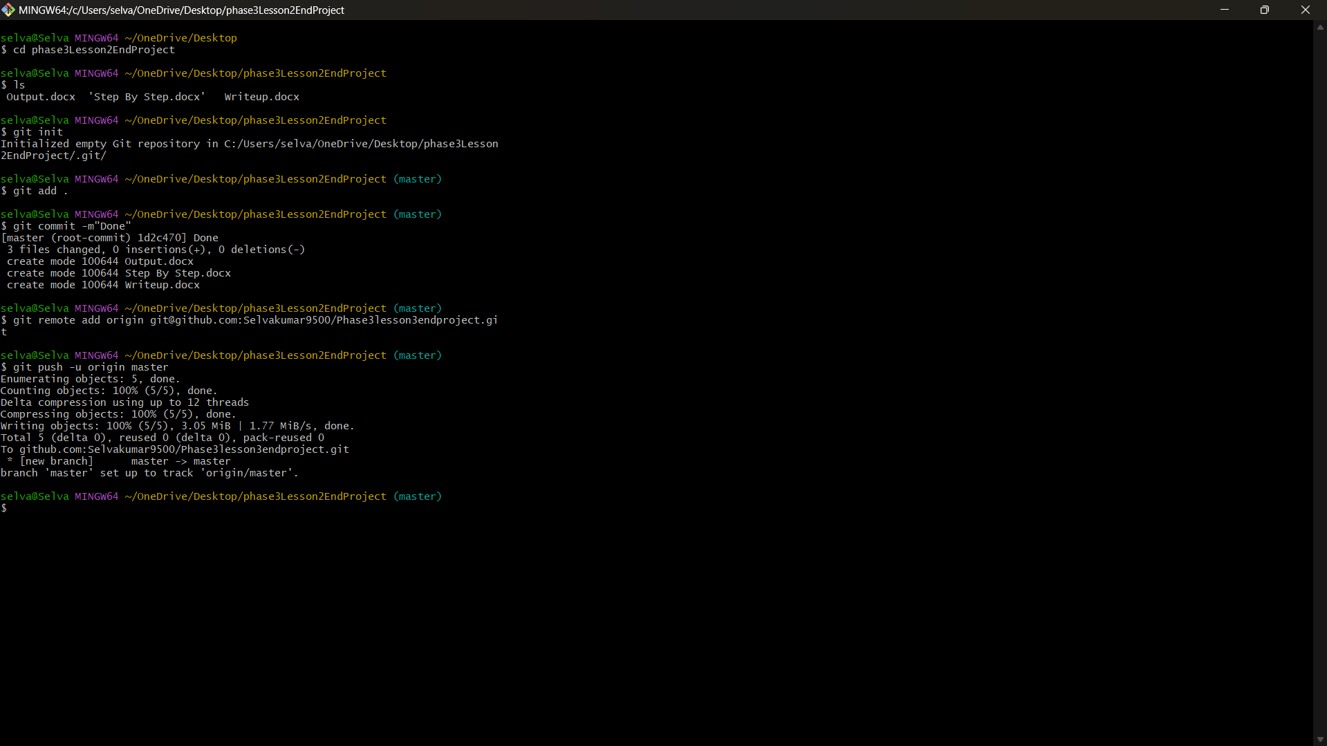

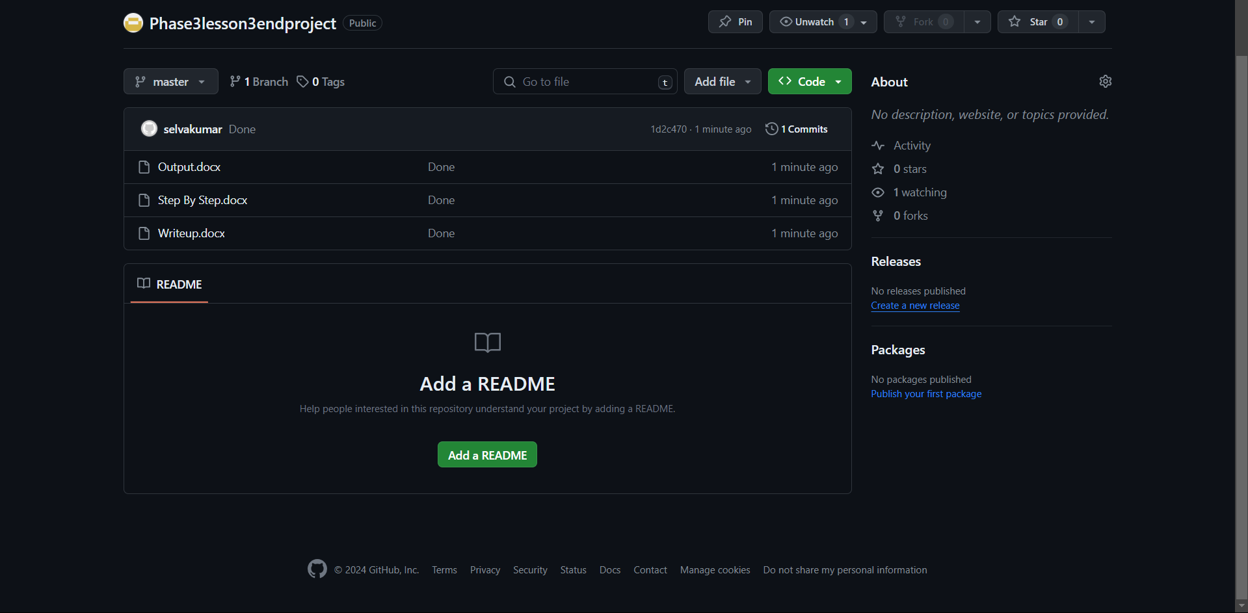

* Github link

<https://github.com/Selvakumar9500/Phase3lesson3endproject.git>